**1. What does an empty dictionary's code look like?**

**Ans 1:** An empty dictionary in Python is represented by curly braces **{}** with no key-value pairs inside.

Eg : empty_dic = {}

**2. What is the value of a dictionary value with the key 'foo' and the value 42?**

**Ans 2 :** The value of a dictionary with the key ‘foo’ and the value 42would be 42.

Eg: my_dic = {‘foo’ : 42}

print(my_dic[‘foo’]) # result is 42

**3. What is the most significant distinction between a dictionary and a list?**

**Ans 3:**

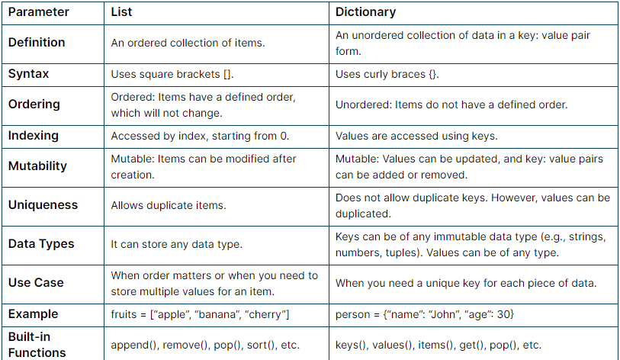

**4. What happens if you try to access spam['foo'] if spam is {'bar': 100}?**

**Ans 4 :** This will through KeyError as key ‘foo’ is not defined in the dictionary.

**5. If a dictionary is stored in spam, what is the difference between the expressions 'cat' in spam and 'cat' in spam.keys()?**

**And 5:**

1. **'cat' in spam :**

This expression checks whether the key ‘cat’ exists in the dictionary ‘spam’

If the key ‘cat’ exists in spam, regardless of its associated value, the expression evaluates to TRUE. Otherwise, it evaluates to FALSE.

spam = {‘cat’:1,’dog’:2,’mouse’:3}

print(cat in spam) ## returns TRUE

1. **'cat' in spam.keys():**

This expression checks whether the key **'cat'** exists in the dictionary **spam** by explicitly checking against the keys of the dictionary.

It is functionally equivalent to the first expression but explicitly checks against the keys of the dictionary.

**6. If a dictionary is stored in spam, what is the difference between the expressions 'cat' in spam and 'cat' in spam.values()?**

**Ans 6:** Same as answer 5.

**7. What is a shortcut for the following code?**

**if 'color' not in spam:**

**spam['color'] = 'black'**

**Ans 7:** We can use the setdefault() method to achieve the same functionality in a more concise way. Here's the shortcut:

spam.setdefault(‘color’,’black’)

It will set the default value of color to black if color is not in spam otherwise if color is present in spam it will not set any value.

**8. How do you "pretty print" dictionary values using which module and function?**

**Ans 8:** We can use the pprint module in Python to "pretty print" dictionary values.

Eg ; import pprint

my_dict = {‘a’;1,’b’:2,’c’:3,{‘x’:4,’y’:6}}

pprint.pprint(my_dict)